caXchange Administration Tool

caXchange 2.0
Ekagra Software Tech.

Technical Architecture Guide


Updated November 13, 2008

DOCUMENT CHANGE HISTORY
Version Number | Date | Contributor | Description
1.0 | 11/12/2008 | Harsh Marwaha | Initial Draft

TABLE OF CONTENTS
1 Introduction 3
1.1 Related documents 3
2 Overview of the Software 4
2.1 Software Overview 4
2.1.1 Project Background 4
2.1.2 System Overview 4
2.2 System Requirements 5
3 caXchange Administration Tool Installation 6
4 caXchange Administration Tool Architecture 7
4.1 System Architecture Overview 7
4.2 Architectural Design 8
5 caXchange Administration Tool Design 9
5.1 caXchange ADMINISTRATION TOOL 9
5.1.1 Use Case 9
5.1.2 Logical Design 9
5.1.3 Authentication/Authorization 9
5.2 Technology Stack 9
Technical Manuals/Articles 11
caBIG Material 11
caCORE Material 11
List of Figures
Figure 1 caXchange administration tool interaction with external components 7
Figure 2 caXchange Administration tool component diagram 8

List of Tables
Table 4 - High Level Summary of Requirements 5

Introduction
The caXchange Administration tool provides a graphical user interface for configuring and monitoring caXchange. This tool provides functionality to configure caXchange routing. Using this tool caXchange routing can be configured for new service types, and new target services. Service types can be configured to add or remove transaction control and payload validation.
This Technical Architecture Guide provides the software architecture and high level design for the caXchange Administration tool. This document is meant to be a recommendation and guideline to the development team to develop a detailed design for the system.

Related documents
For additional project information, please refer to the following documents:
- caXchange Software Requirements Specification (SRS)
- caXchange Use Case Specification and Realization Document
- caXchange Design Document
- caXchange Installation Guide
- caXchange Administration Guide
The latest versions of these documents can be found in:
https://gforge.nci.nih.gov/plugins/scmcvs/cvsweb.php/caxchange/Deliverables/?cvsroot=caxchange

Overview of the Software

Software Overview

Project Background
The caXchange hub provides this capability by using standard service hub protocols and messaging formats to receive, route, log, and send messages and data between applications. caXchange version 1.5 externalized routing configuration making the caXchange Hub a highly configurable software. In caXchange 1.5 an administrator can modify the configuration files to configure new service types, and new target services. These changes can be done without the need for a developer to rebuild the caXchange software. However caXchange modifying caXchange configuration involves making changes to multiple XML and properties files, changing database entries, verifying the changes and restarting the software. It is expected that these changes will be infrequent so the administrator does not have a need to familiarize with caXchange configuration. Additionally caXchange configuration is dependent on the underlying routing technology. Changing the caXchange routing technology will require caXchange administrators to learn the configuration of the new technology.
This project focuses on the development of an open-source, graphical user interface solution for configuring caXchange.

System Overview
Goal of this project is to build a caXchange Administration tool that provides a graphical view to editing caXchange configuration. The software components used to build this web application are included in the CBIIT current/future technology stack. A caXchange administrator can use this software to perform the following tasks:
- View caXchange configuration.
- Add a new service type.
- Add a new target service.
- Configure a service type for transaction control.
- Configure a service type for payload validation.
- Configure a service type for proxy delegation.
- Monitor caXchange performance.

System Requirements
The following table provides a very high-level summary of the requirements of the caXchange system:
Table 1 - High Level Summary of Requirements
Requirement ID | Requirement Description
1.0 | The caXchange Administration tool must provide an ability to view caXchange configuration.
2.0 | Access to the caXchange Administration tool should be secure.
3.0 | The caXchange Administration tool must provide an ability to configure a new service type.
4.0 | The caXchange Administration tool must provide an ability to configure service types within caXchange.
5.0 | Ability to restore caXchange configuration from backup to rollback any changes.
6.0 | Monitor the performance of caXchange and target services.

A more detailed understanding of the requirements can be found in the requirements document: caXchange Project Software Requirements Specification. caXchange Administration tool use cases expand on these requirements, These use case documents are included in the related documents section.

caXchange Administration Tool Installation
caXchange Administration tool will be deployed as a web application on the tomcat container. This web application will share the tomcat container with the caXchange inbound grid service. Further for access to caXchange configuration files caXchange administration tool is required to be deployed on the same machine as the caXchange hub software for access to the configuration files.

caXchange Administration Tool Architecture

System Architecture Overview
- Figure 1 shows a high-level component diagram for the caXchange Administration tool. This diagram shows the software interaction with external components. This diagram also shows how the caXchange Administration tool will be deployed in relation to other caXchange components.
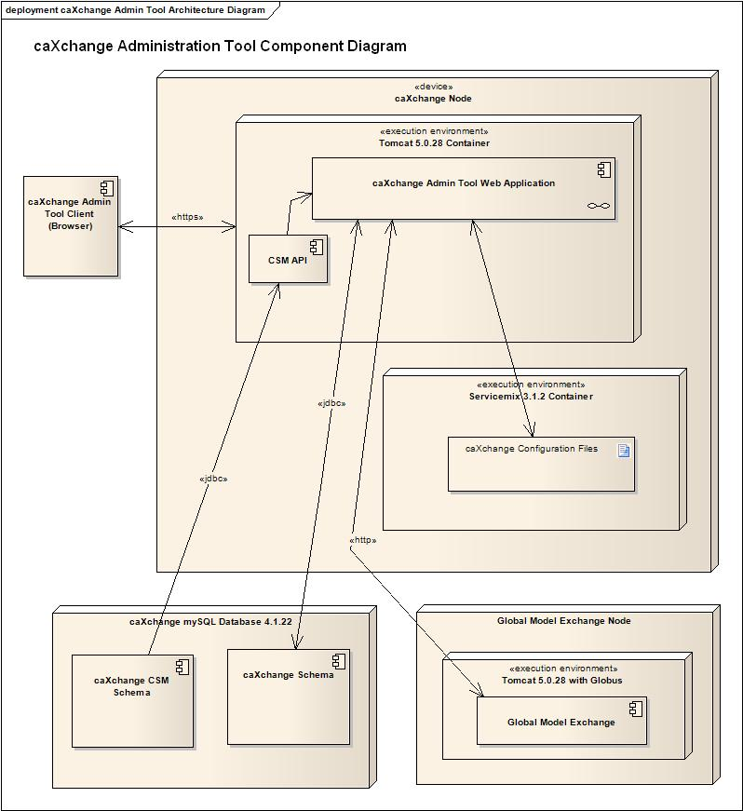
Figure 1 caXchange administration tool interaction with external components

Architectural Design
caXchange Administration tool is designed as a web application. A caxchange administrator logs into the administration tool and makes changes to caXchange configuration. These changes are then applied to caXchange. caXchange is restarted for the configuration changes to take effect. The versions of the open source technological components used to develop this software are as noted in the NCI CBIIT technology stack. The web application architecture is designed using a Model View Controller (MVC) approach. The architecture is designed so that the changes to the caXchange hub software require minimal changes to the administration tool.

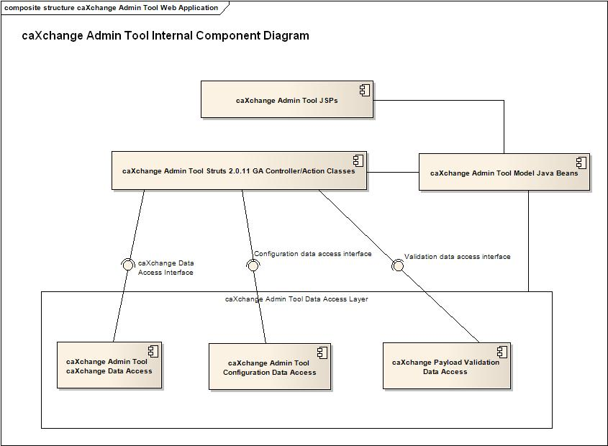
Figure 2 caXchange Administration tool component diagram

The figure above shows the high level architecture design. The key points for the architecture are:
- A set of java beans that are used to pass data between the model, view and controller layers.
- A set of interfaces defining data access for the controller layer. The implementations of these interfaces can be changed if caXchange configuration files or other data sources change.

caXchange Administration Tool Design

caXchange ADMINISTRATION TOOL

Use Case

Logical Design

Authentication/Authorization
Authentication and authorization for the administration tool will be configured using the caXchange CSM (Common Security Module). The CSM API will be used to configure authentication and authorization to the web application.

Technology Stack
The following technologies are used in the development, deployment and use of caXchange administration tool:

Technological Component | Version
Apache Tomcat | 5.0.28
JEE (Jave Enterprise Edition) | 1.4
MySQL | 4.1.22
IE Browser | 7.0
Mozilla Browser | 2.0.0.1
HTML | 4.0.1
Common Security Module (CSM) | 4.0
Java Platform | 1.5.0_10
Ant | 1.6.5
Maven | 2.0.8
Version Control | CVS
Junit | 4.2
Spring Framework | 2.0.2
Struts Framework | 2.0.11 GA
Table 2 caXchange Administration Tool technology stack.

The versions of these software components were used in accordance with the NCI CBIIT technology stack. The current and future NCI CBIIT technology stack can be found here:

http://gforge.nci.nih.gov/docman/index.php?group_id=27&selected_doc_group_id=460&language_id=1

Appendix A References

Technical Manuals/Articles
- National Cancer Institute. “caCORE SDK 3.2 Programmers Guide”: http://ncicb.nci.nih.gov/infrastructure/cacoresdk
- Java Bean Specification: http://java.sun.com/products/javabeans/docs/spec.html
- Foundations of Object-Relational Mapping: http://www.chimu.com/publications/objectRelational/
- Object-Relational Mapping articles and products: http://www.service-architecture.com/object-relational-mapping/
- Hibernate Reference Documentation: http://www.hibernate.org/hib_docs/reference/en/html/
- Basic O/R Mapping: http://www.hibernate.org/hib_docs/reference/en/html/mapping.html
- Java Programming: http://java.sun.com/learning/new2java/index.html
- Javadoc tool: http://java.sun.com/j2se/javadoc/
- Junit: http://junit.sourceforge.net/
- Extensible Markup Language: http://www.w3.org/TR/REC-xml/
- XML Metadata Interchange: http://www.omg.org/technology/documents/formal/xmi.htm

caBIG Material
- caBIG: http://cabig.nci.nih.gov/
- caBIG Compatibility Guidelines: http://cabig.nci.nih.gov/guidelines_documentation

caCORE Material
- caCORE: http://ncicb.nci.nih.gov/core
- caBIO: http://ncicb.nci.nih.gov/core/caBIO
- caDSR: http://ncicb.nci.nih.gov/core/caDSR
- EVS: http://ncicb.nci.nih.gov/core/EVS
- CSM: http://ncicb.nci.nih.gov/core/CSM
Appendix B Glossary
Term | Definition
{jboss-home} | The base directory where Jboss is installed on the server
API | Application Programming Interface
caBIG | cancer Biomedical Informatics Grid
caBIO | Cancer Bioinformatics Infrastructure Objects
caCORE | cancer Common Ontologic Representation Environment
cardinality | Cardinality describes the minimum and maximum number of associated objects within a set
CDISC | Clinical Data Interchange Standards Consortium
CSM | Common Security Module
CTMS | Clinical Trial Management Systems
CVS | Concurrent Versions System
DAO | Data Access Objects
DAS | Distributed Annotation System
EA | Enterprise Architect
EBI | European Bioinformatics Institute
EVS | Enterprise Vocabulary Services
GULCCC | Georgetown University Lombardi Cancer Center
HIPPA | Health Insurance Portability and Accountability Act
HTTP | Hypertext Transfer Protocol
ISO | International Organization for Standardization
JAAS | Java Authentication and Authorization Service
JAR | Java Archive
Javadoc | Tool for generating API documentation in HTML format from doc comments in source code (http://java.sun.com/j2se/javadoc/)
JBI | Java Business Integration
JDBC | Java Database Connectivity
JET | Java Emitter Templates
JMI | Java Metadata Interface
JSP | JavaServer Pages
JUnit | A simple framework to write repeatable tests (http://junit.sourceforge.net/)
LDAP | Lightweight Directory Access Protocol
LLT | Log Locator Tool
LOINC | Logical Observation Identifier Names and Codes
MedDRA | Medical Dictionary for Regulatory Activities
metadata | Definitional data that provides information about or documentation of other data.
Multiplicity | Multiplicity of an association end indicates the number of objects of the class on that end may be associated with a single object of the class on the other end
NCI | National Cancer Institute
NCICB | National Cancer Institute Center for Bioinformatics
OMG | Object Management Group
ORM | Object Relational Mapping
RDBMS | Relational Database Management System
SDK | Software Development Kit
Semantic connector | A development kit to link model elements to NCICB EVS concepts.
SIG | Special Interest Group
SQL | Structured Query Language
UI | User Interface
UID | User Identification
UML | Unified Modeling Language
UMLS | Unified Medical Language System
UPT | User Provisioning Tool
URL | Uniform Resource Locators
WAR | Web Application Archive
WSDL | Web Services Description Language
XMI | XML Metadata Interchange (http://www.omg.org/technology/documents/formal/xmi.htm) - The main purpose of XMI is to enable easy interchange of metadata between modeling tools (based on the OMG-UML) and metadata repositories (OMG-MOF) in distributed heterogeneous environments
XML | Extensible Markup Language (http://www.w3.org/TR/REC-xml/) - XML is a subset of Standard Generalized Markup Language (SGML). Its goal is to enable generic SGML to be served, received, and processed on the Web in the way that is now possible with HTML. XML has been designed for ease of implementation and for interoperability with both SGML and HTML

